**NEURAL NETWORKS:**

A neural network is a series of algorithms that endeavors to recognize underlying relationships in a set of data through a process that mimics the way the human brain operates. Also referred to as Black Box.

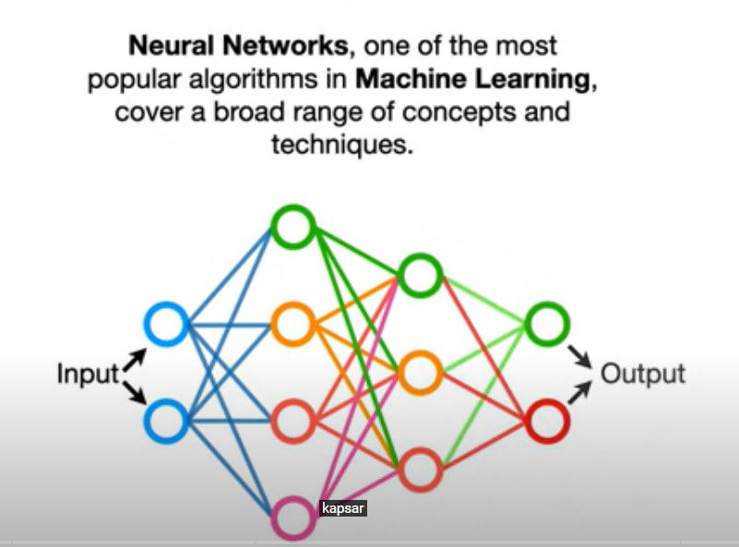

**ACTIVATION FUNCTIONS:**

In lame words, It’s just a thing function that you use to get the output of a node. It is also known as Transfer Function. There are many like sigmoid, RELU(Rectified Linear Activation Unit)-more common and softmax(below).

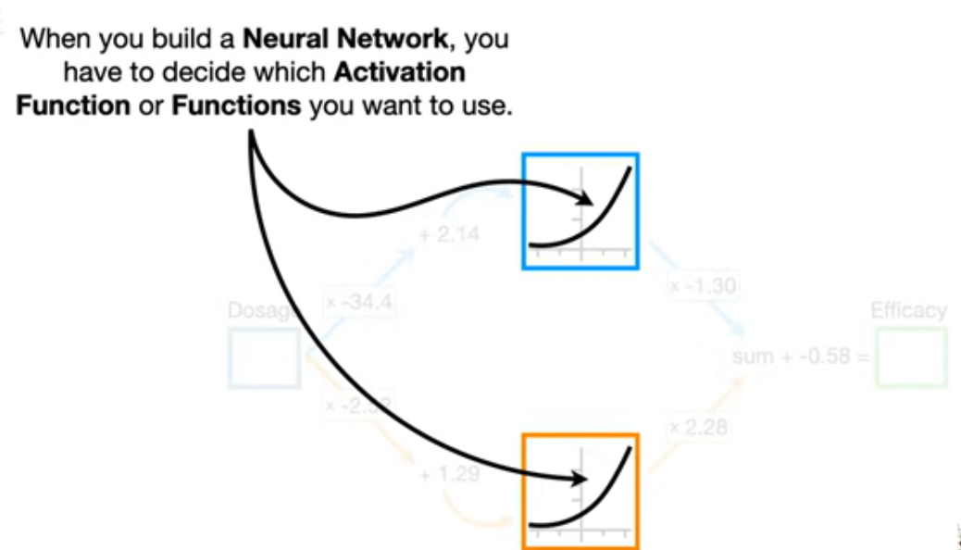

**Reference:**

[**https://towardsdatascience.com/activation-functions-neural-networks-1cbd9f8d91d6**](https://towardsdatascience.com/activation-functions-neural-networks-1cbd9f8d91d6)

**BACKPROPAGATION:**

Backpropagation is the essence of neural network training. It is the method of fine-tuning the weights of a neural network based on the error rate obtained in the previous epoch (i.e., iteration). Proper tuning of the weights allows you to reduce error rates and make the model reliable by increasing its generalization. Backpropagation in a neural network is a short form for “backward propagation of errors.” It is a standard method of training artificial neural networks. This method helps calculate the gradient of a loss function with respect to all the weights in the network.

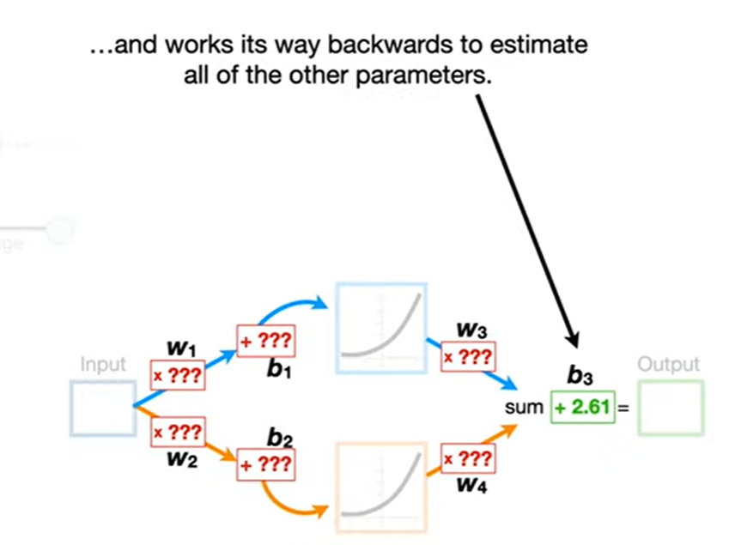

**References:**

[**https://www.youtube.com/watch?v=IN2XmBhILt4**](https://www.youtube.com/watch?v=IN2XmBhILt4)

[**https://www.youtube.com/watch?v=GKZoOHXGcLo&t=626s**](https://www.youtube.com/watch?v=GKZoOHXGcLo&t=626s)